K.R MANGALAM UNIVERSITY

School of Engineering and Technology
Department: CSE
Programme: B.Tech CSE {AI AND ML}
Course Name: ETCCCP105
Session: odd
Semester: 1

Assignment Number 02: Basics of Linux and Open-Source Tools

Assignment Title: How Can You Demonstrate Linux Setup, Command Usage, and Automation Through Practical Implementation?

Submitted by: Kunal Yadav
Submitted to: Mr.Rajesh

Step 1 – Linux Installation
➢ Go to google type Ubuntu desktop download, click on first website.
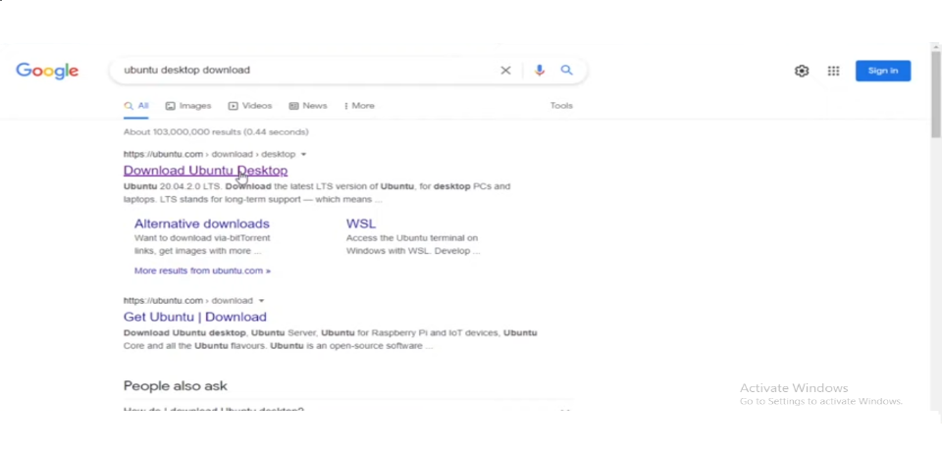
➢Download the latest version of Ubuntu, make sure download the LTS version.
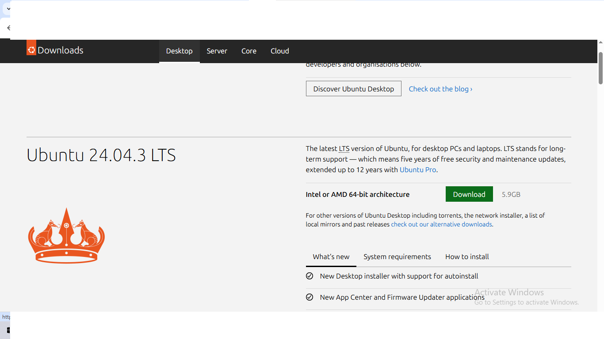
➢ Download is started, it will take few minutes. 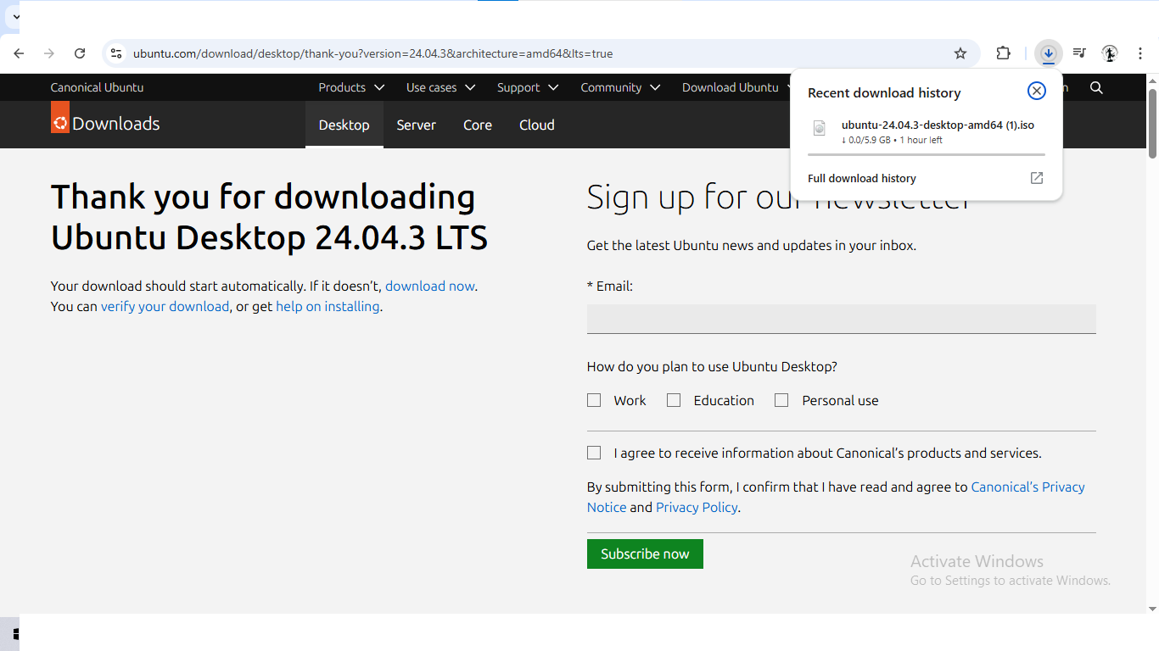
➢ create a virtual machine in virtual box, then click on finish button.
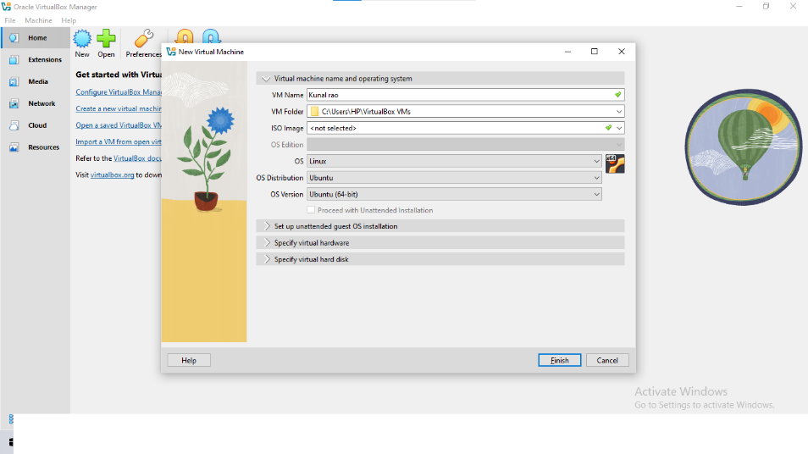
➢ Alloate the hardware configuration details such as CPU, RAM, disk space.

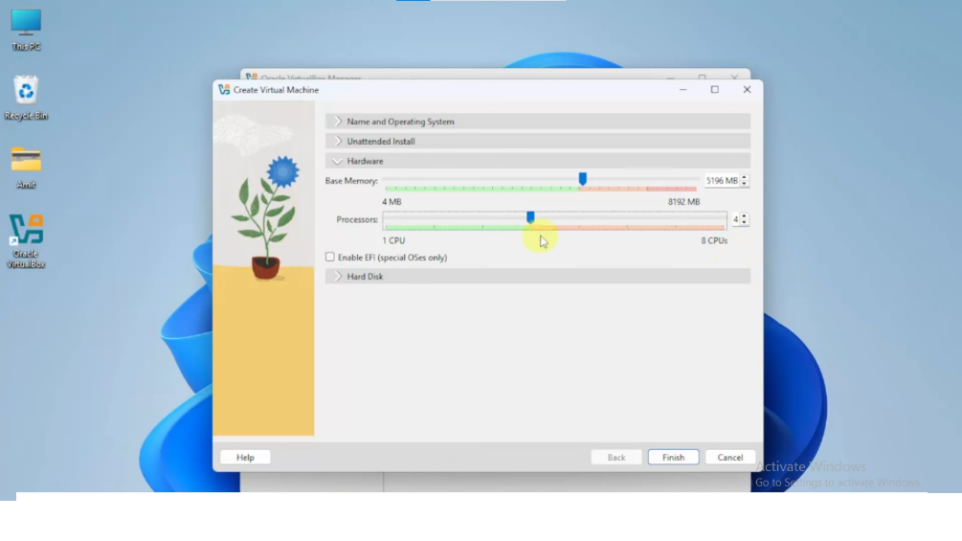
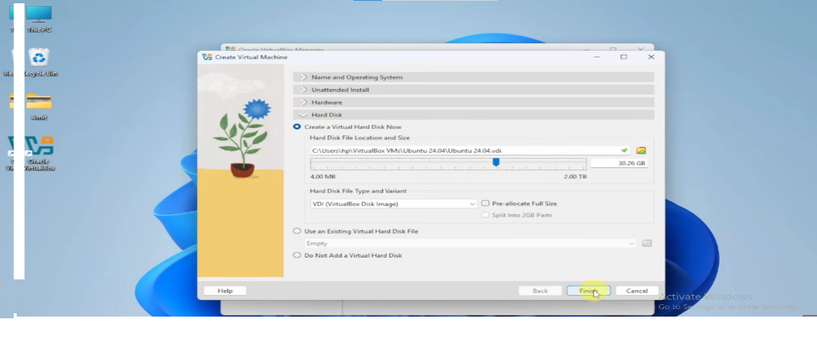

Step 2 - Shell Command Implementation and Documentation

  - a) File Navigation: ls, cd, pwd, tree

  - 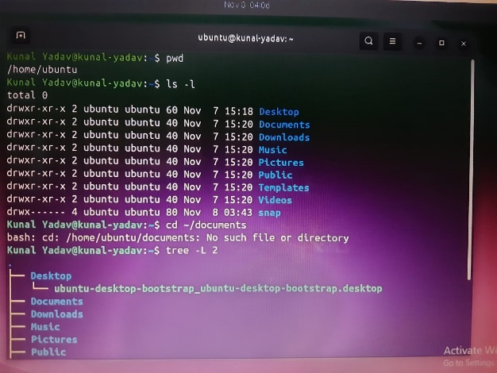

  - 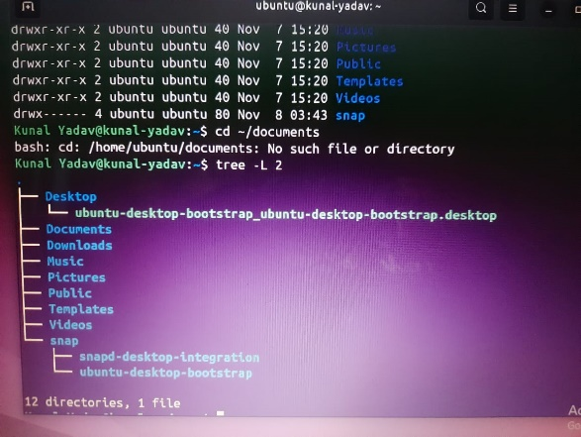

  - a) PWD
Syntax: pwd Description: Print working directory (current path)
When/Why: To confirm your current directory before running file operations.

b)ls
Syntax: ls [options] [path] Description: List directory contents.
When/Why: See files and permissions; use -l for details, -a to show hidden files

c)cd
cd [directory] Description: Change the current directory
When/Why: Navigate filesystem.

d)tree
Syntax: tree [options] [directory] Description: Show directory structure as a tree (may need sudo apt install tree)
When/Why: Visualize directory hierarchy.

b) File and Directory Management: mkdir, touch, cp, mv, rm

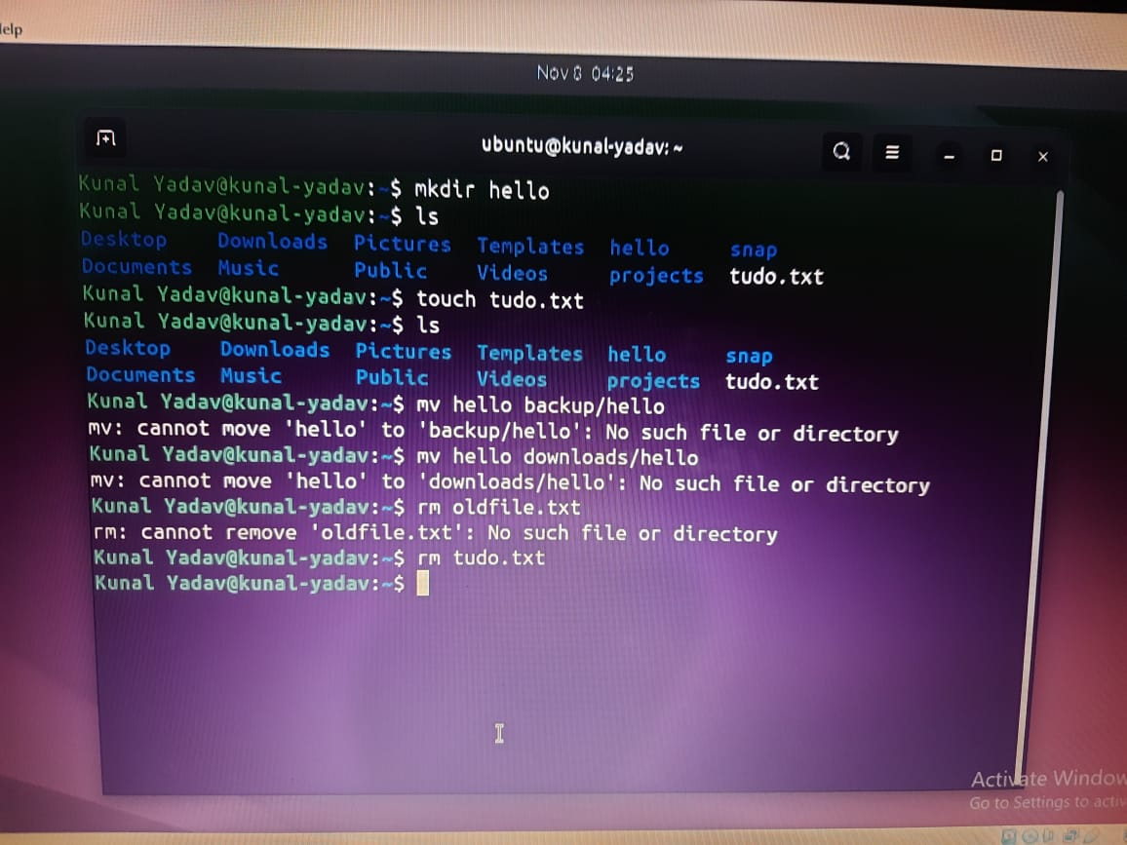

e)mkdir
Syntax: mkdir [options] directory Description: Create a directory.
When/Why: Create folders for organization.

f)touch
Syntax: cp [options] source dest Description: Copy files or directories (-r for recursive).
When/Why: Make backups or duplicate files.

g)mv
Syntax: mv source dest Description: Move or rename files/directories
When/Why: Move files into other directories or rename.

h)rm
Syntax: rm [options] files Description: Remove files. -r recursive; -f force.
When/Why: Delete unwanted files — be careful (no recycle bin by default).

c) Permissions Management: chmod, chown

  - 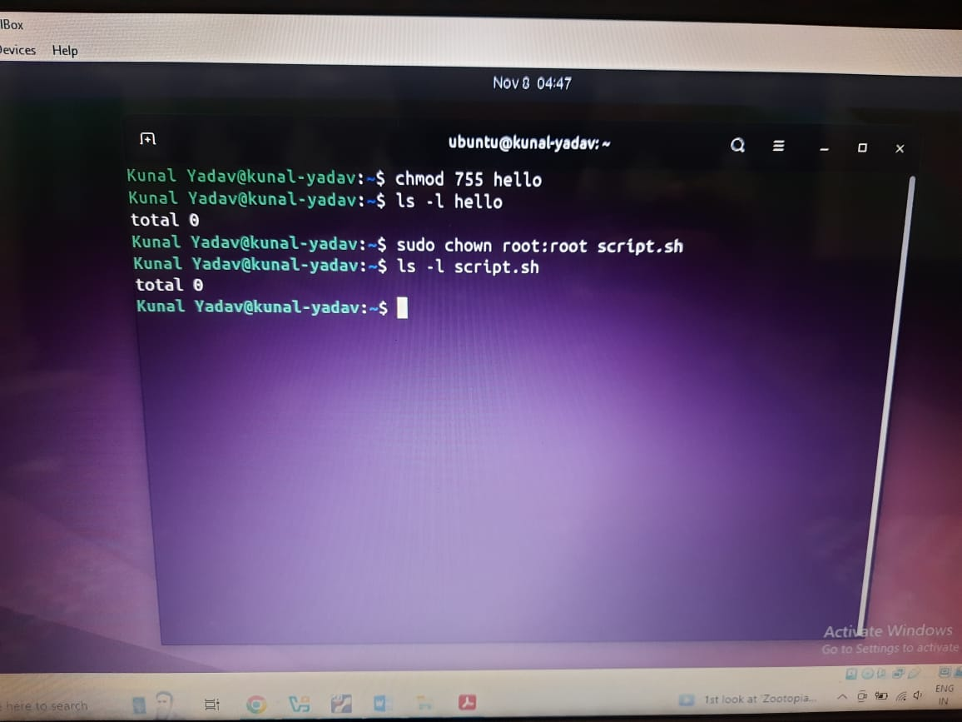

i)chmod
Syntax: chmod [options] mode file Description: Change file permissions.
When/Why: Make scripts executable or adjust access rights.

j)chown
Syntax: chown [options] user[:group] file Description: Change file owner and/or group.
When/Why: Required when assigning ownership to another user (often sudo needed).

d) Process Monitoring: ps, top, kill

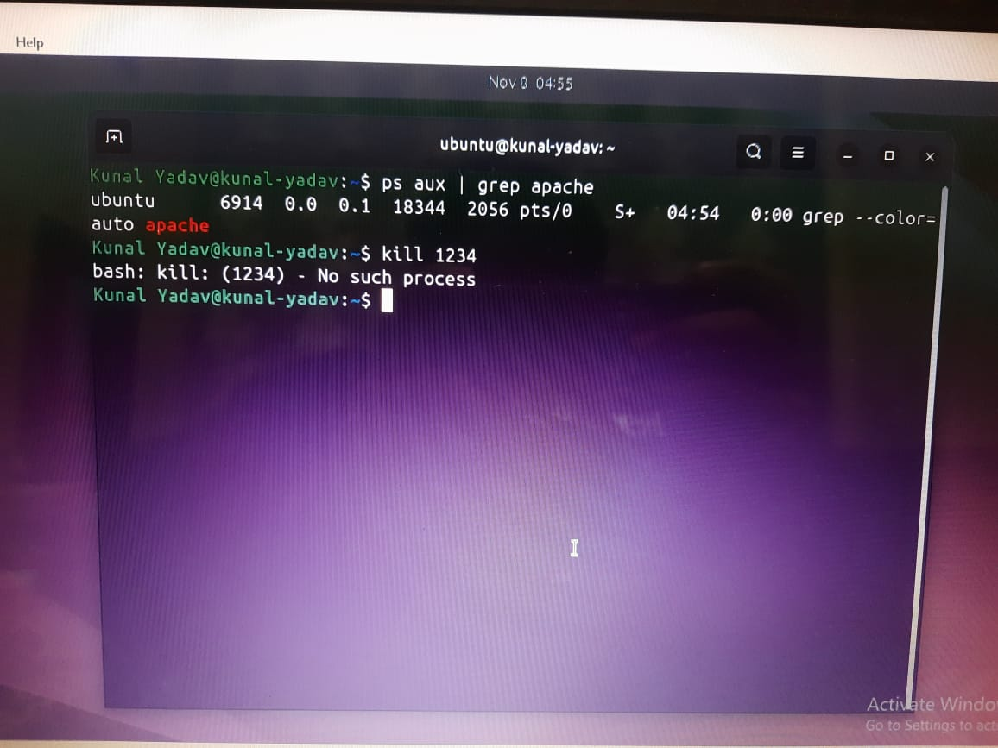

k)ps
Syntax: ps [options] Description: Show current processes. Common: ps aux.
When/Why: Inspect running processes; find PIDs to kill or debug services.

l)Top
Syntax: top Description: Interactive real-time system monitor.
When/Why: Monitor CPU/memory usage and identify heavy processes.

m)kill
Syntax: kill [options] PID Description: Send signals to processes (default SIGTERM).
When/Why: To stop malfunctioning processes.

E) Networking Tools: ping, ifconfig / ip, netstat

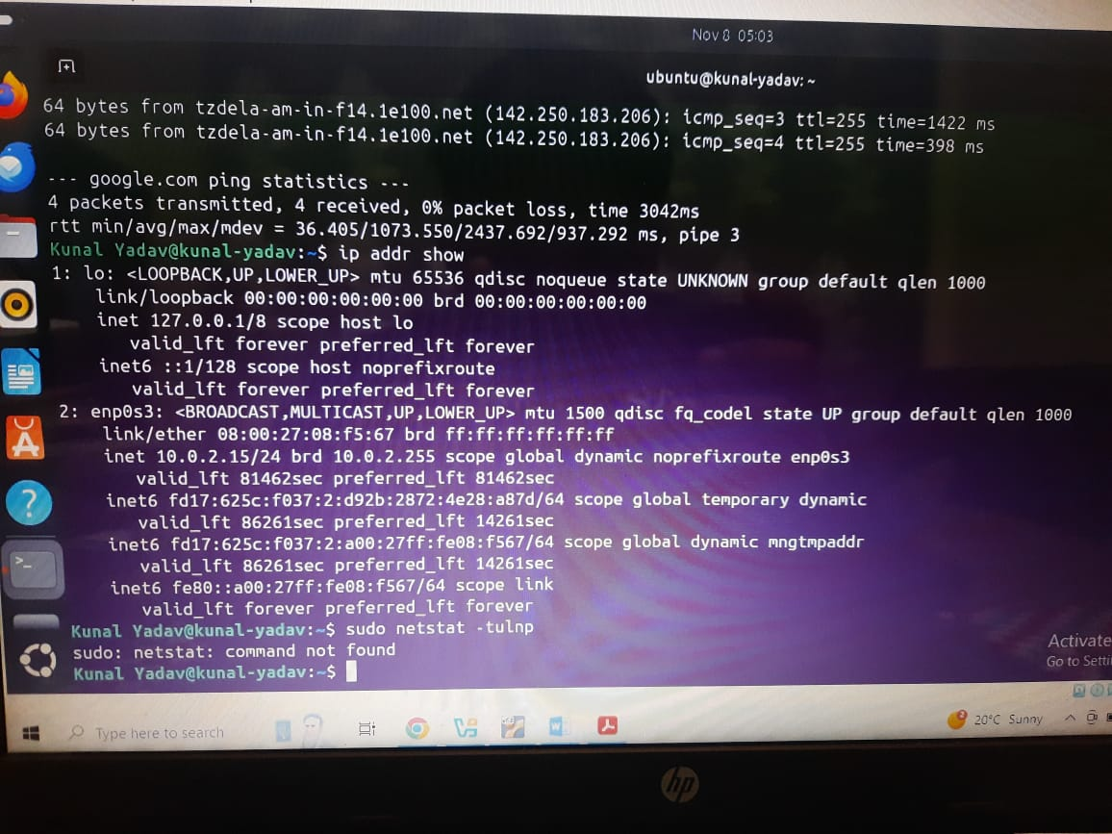

n)ping
Syntax: ping [options] host Description: Send ICMP echo requests to test connectivity.
When/Why: Quick network reachability test.

o) ifconfig
Syntax: ifconfig or ip addr show Description: Show network interfaces and addresses.
When/Why: Check IP addresses and interface status.
p) netstat
Syntax: netstat -tulnp or ss -tulnp Description: Show open ports and listening services.
When/Why: Troubleshoot network services and ports.

F) File content & searching

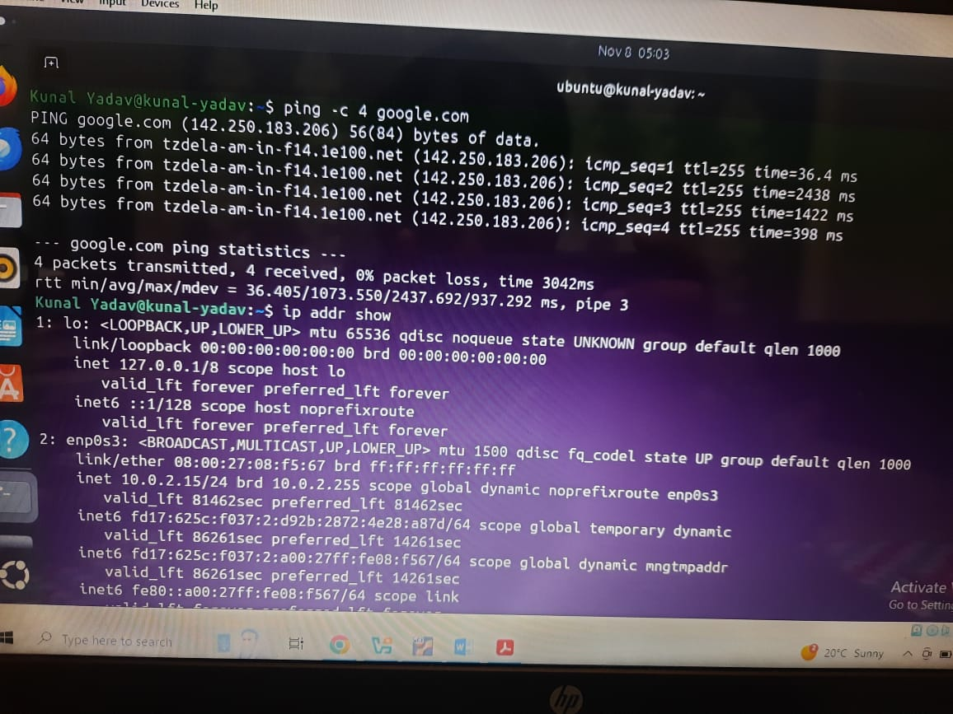

q)cat
Syntax: cat file Description: Display file content.
When/Why: Quickly view small files.

r)less
Syntax: less file Description: View file with paging and search (/pattern).
When/Why: Inspect long log files.

s)grep
Syntax: grep [options] pattern file Description: Search text using patterns
When/Why: Filter command output and search logs.

t)tar
Syntax: tar [options] archive.tar files Description: Create/extract tar archives.
When/Why: Bundle and compress directories for backup or transfer.

Step3) Shell Script Development

- a)Backup a Directory: (backup_dir.sh)
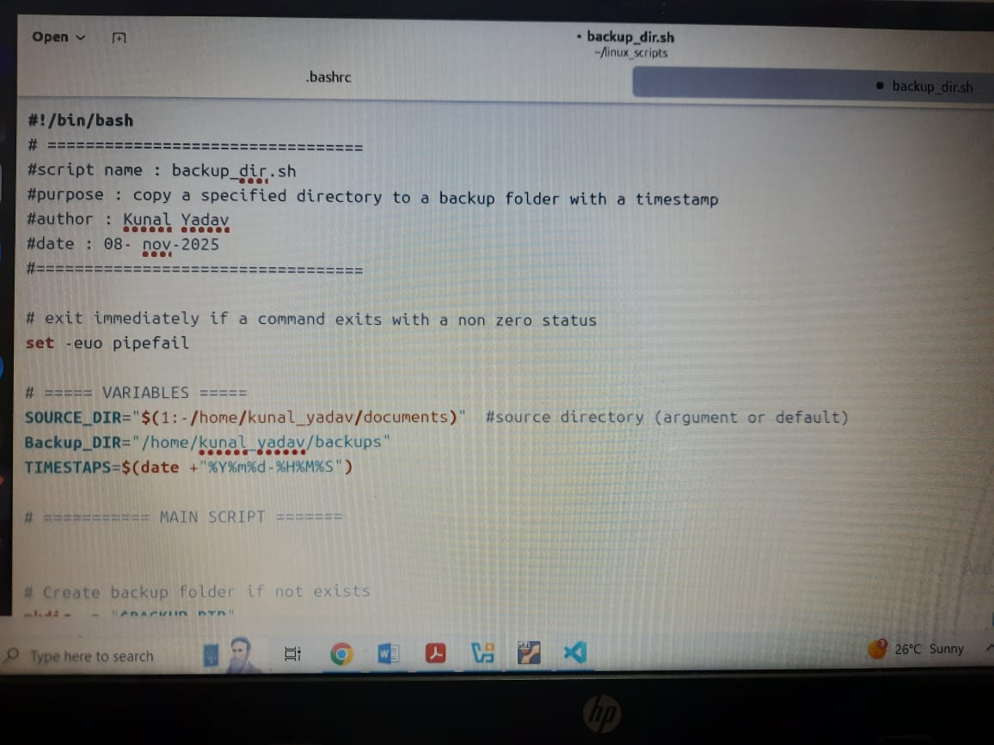

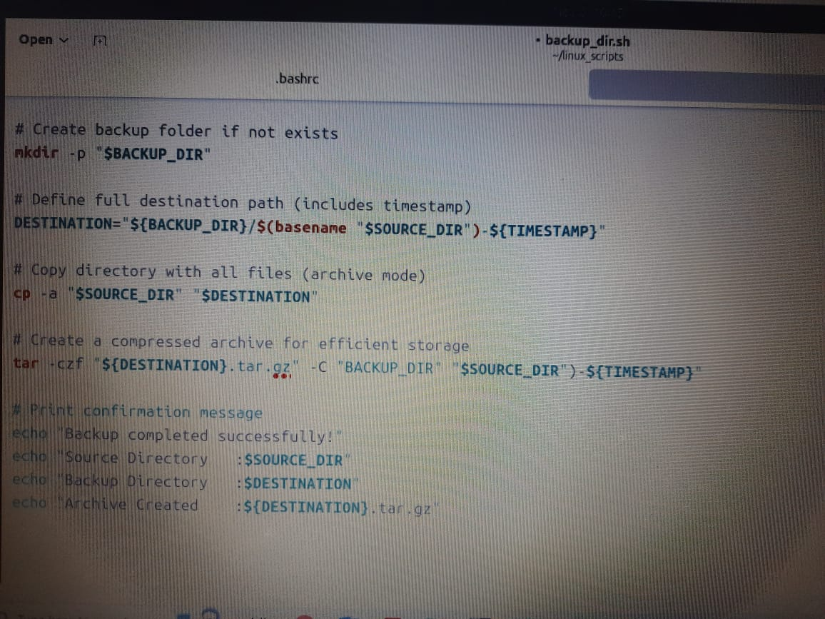

B) Script 2 – CPU/Memory Monitoring (cpu_mem_monitor.sh)

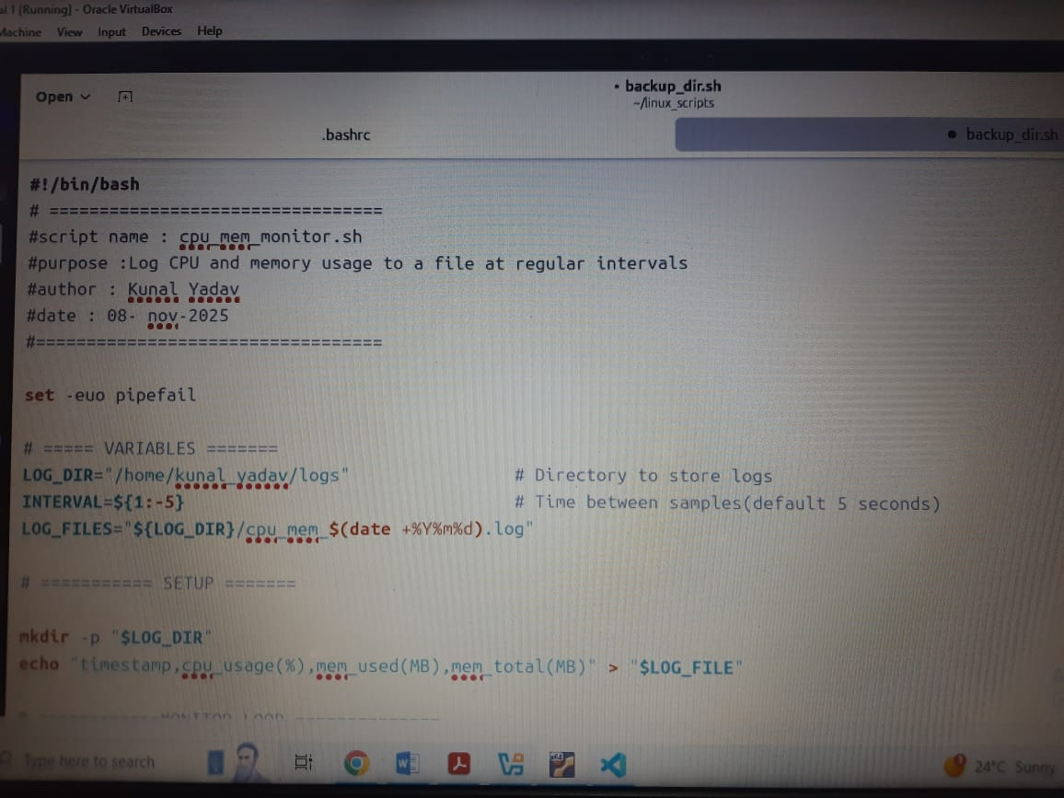

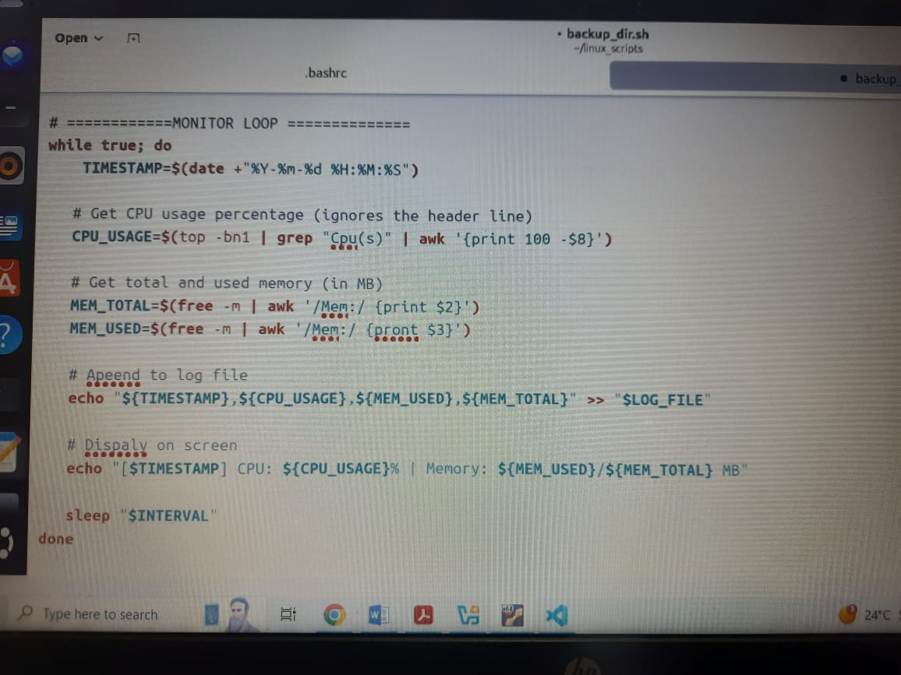

c) Script 3 – Automated Download Task ( auto_downloads.sh)

